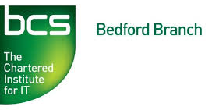
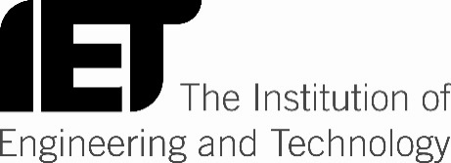

Brex-IT:
How to do IT?
Dalim Basu
Chairman, BCS North London Branch

Tuesday, 14th March 2017
6.30-8.00pm
(Registration starts at 6:30pm)
Tavistock Suite
The Park Inn Hotel, 2 St Mary's Street,
Bedford MK42 0AR
(Free Parking at the rear – Inform Hotel Reception)
Register online at: https://events.bcs.org/book/2438/
An interactive hour with Dalim Basu and Bedford Branch colleagues.

How can we help UK organisations to understand and manage their ICT-related challenges and risks in the uncertain transition process toward and through Brexit, and to benefit from a new world of opportunities?

Come to join us to learn and contribute to views about this important topic.

Dalim Basu CISA, CRISC, FBCS, CITP, BSc.(Hons.)
Chairman, BCS North London Branch
Events Director, ISACA London Chapter
Director, DSL IT Risk Management Consultancy

Dalim is an IT professional with expertise in IT Governance and Risk Management. His experience includes IT audit, compliance, controls, security, PMO and project management.

He is a Director of DSL IT Risk Management Consultancy, and has worked in the UK and other countries for major financial and business services firms such as PwC, KPMG, Chase Manhattan Bank, ITN, Lehman Brothers, Lloyds Banking Group, Mitsubishi, Mizuho Bank, Nomura, Shell and Zurich Financial Services.

As voluntary activities, for many years Dalim has been Chairman of the dynamic North London Branch (NLB) of BCS, The Chartered Institute for IT; and also a judge of BCS/Computing ‘UK IT Industry Awards’. He is the Events Director of ISACA London Chapter. He also mentors and guides IT students, innovators and entrepreneurs at London University and elsewhere.

Dalim is a firm believer in the high value of IT professionalism and actively encourages and promote it at many levels – including at events and conferences with various organisations in the UK and overseas.

Agenda
6.30pm Registration, refreshments and networking
7.00pm Guest Speaker – Dalim Basu
8.00pm Opportunity to network and talk to the speaker

