BCS (Bedford Branch) Cyber Challenge

Prize Presentation
50 students, teachers and parents attended the 2022 Cyber Challenge competition prize presentation at the Digital Aviation Research and Technology Centre at Cranfield University on 7 July 2022.
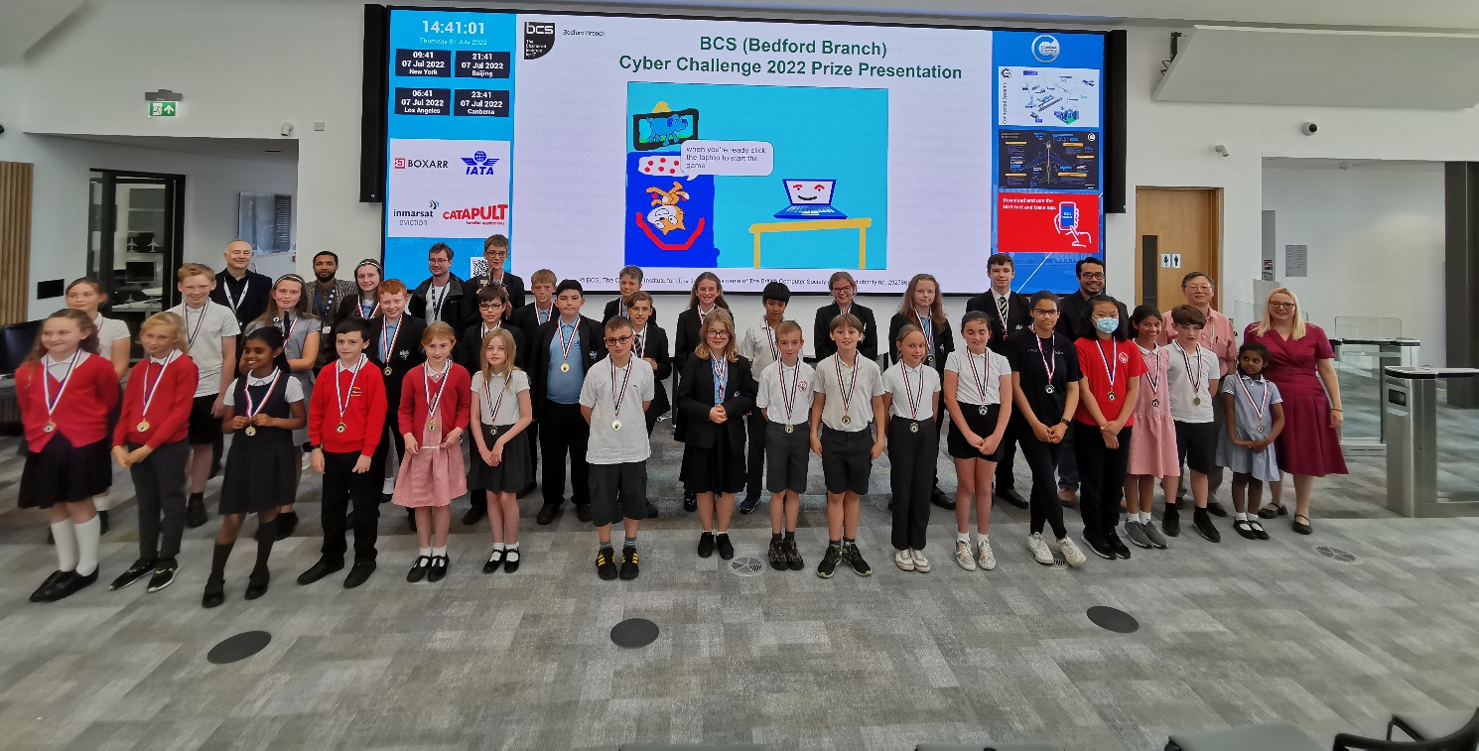
Since 2013, the BCS Bedford Branch has been running a competition to cultivate young computing leaders. The competition is open to all Year 5 to Year 10 students from schools in the areas of Bedford Borough, Central Bedfordshire, Luton Borough, Milton Keynes and Buckinghamshire.
160 entries were received from schools in the areas of Bedford Borough, Central Bedfordshire, Luton Borough, Milton Keynes and Buckinghamshire. The judges were looking for:
- Creativity
- Selection use, combination and presentation of images and text
- The appropriate choice and use of programming instructions and should include Custom blocks, Loops and Variables
- The clarity of the finished presentation in demonstrating improved learning outcomes

The submission quality is very high, and the judging panel had to make difficult choices.

Selected quality entries were shown off to inspire the future computing leaders. Jayla from Mark Rutherford shared how she has gained from her competition experience and looking forward to starting her computing career in a game development company.

The award winners are:

 | First | Second | Third
Year 5 | Emilia and Amy Heatherton Prep School | Avni & Daisy  Hills Academy | Seb  Hills Academy
Year 6 | Josh F, Issy M, Franklin  Leighton Middle School | Greta  High Ash CE School | Alfie  Hills Academy
Year 7 | Ava P, Naomi O, Sarah J & Rabiya R Watling Academy | Mia J & Zaina S Watling Academy | Isha & Ope  Watling Academy
Year 8 | Camila, Lara & Sophie  Watling Academy | Ayaan W & Hakan D Watling Academy | Jenisha, Kiera, Sian & Evelyn  Watling Academy
Year 9 | Harry  Bedford School | Alex  Mark Rutherford
Year 10 | Harrison  Mark Rutherford | Octavia  Mark Rutherford

After the prizes were presented, the visitors toured the Cranfield 737 Ground Demonstrator and the Digital MRO Laboratory.

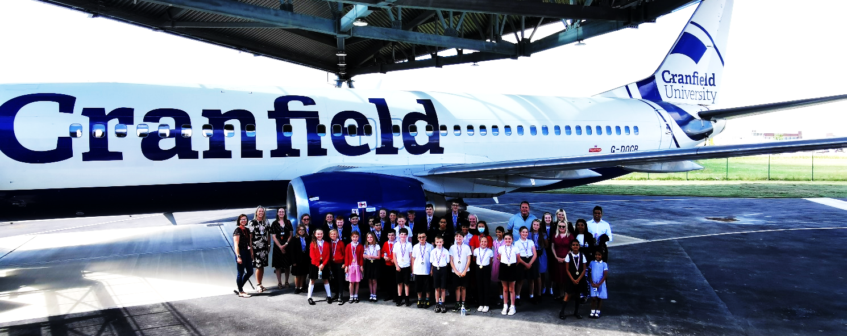

The Bedford Branch committee congratulates the students, their teachers and parents who supported them. We look forward to seeing them again at the 2023 competition.

Dr Ip-Shing Fan, chair of the BCS Bedford Branch said: “There’s a huge computing skills shortage in the UK and this competition aims to inspire young people to think about careers in IT, by developing their skills. We work with the teachers support networks to improve the computing learning experience in our local schools.”

