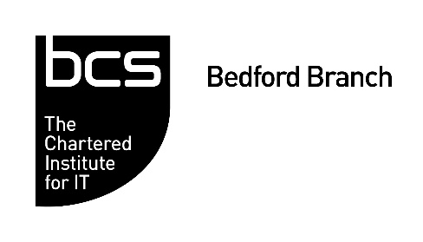
Practical Computing in a GP practice

Dr Gaurang Patel

Thursday, 8th December 2022
7.00 – 8.30pm
Online
(Registration starts at 6:45pm)

Register online at: https://bedford081222.eventbrite.co.uk
Dr Gaurang Patel received the 2021 BCS Student Prize for his Open University thesis project. His thesis work created the Health Manager, a Java network application to analyse and manage chronic disease patients. NHS and the local Clinical Commissioning Group (CCG) provide the GP practice with multiple tools to search for patients in different chronic disease registers and arrange care appointments and tests. The surgery needs to re-assemble the patient information for various reporting. As the tools available do not coordinate with each other, the practice ends up duplicating work. Dr Patel planned and designed the Health Manager to solve this problem by consolidating different searches in one application. The work illustrates how citizen IT is making an impact on GP practice efficiency. This talk presents the Health Manager and Dr Patel’s journey from a medical GP to a developer of medical applications. Health professionals can learn about applications they can add to their workplace. The wider computing community can take inspiration from using our skills to make practical improvements in our workplace.

Dr Gaurang Patel is a practising NHS GP in a busy surgery. He is also the recipient of the BCS Student Prize to Open University for Best Computing and IT Project. He qualified as a medical doctor in 1998. He completed his diploma in General Practice in 2005 and started working as a GP in a busy London practice. Since using self-help resources to fix a PC, he continues to self-learn and builds practical solutions for the practice. He completed his Open University Computing and IT BSc in 2021.

Agenda
6.45pm | Sign in – Welcome – Networking
7.00pm | Practical Computing in a GP practice
7:45pm | Q & A and Networking
8.30pm | CLOSE

