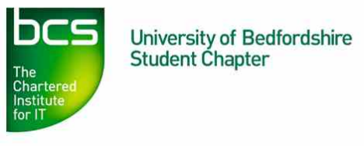
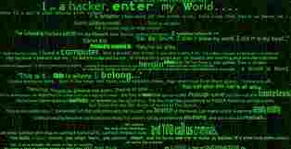
Computer Security and
The University of Bedfordshire’s BCS Student Chapter presents….
Ethical Hacking
(Lecture and Demo)
by
Geraint Williams
Information Risk Consultant, IT Governance Ltd, Honorary Visiting Fellow at the University of Bedfordshire
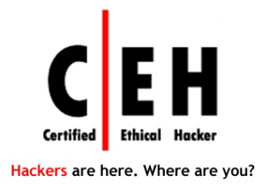
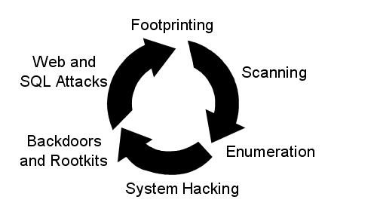
Wednesday 25 February 2015
5.00pm – 6.30pm
Room A310
Everyone is welcome Please register at: https://events.bcs.org/book/1416/

