Ransomware – Kill Chain and Defence! – Thursday, 14 November 2019 6.00-8.00pm

Presentation on Thursday 14 November, 6.00-8.00pm, Room A004
Speaker: Geraint Williams, CISO, GRC International Group.

Arranged by the CST School’s BCS Student Chapter / Beds Computing SU Society

Venue: Park Square Campus, University of Bedfordshire, University Square, Luton LU1 3JU

See https://www.beds.ac.uk/contactus/directions/ for directions

On arrival, please report to the Park Square Campus Reception

For further details, contact paul.sant@beds.ac.uk

Please register to attend this talk at: https://ransomware-kill-chain-and-defence.eventbrite.com

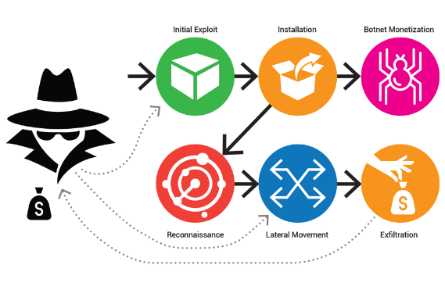
Ransomware has been a major threat to organisations and individual over the last few years. Infections waned at the end of last year but have risen in the first half of this year with new code innovations and much more targeted approach being deployed.

The LockerGoga ransomware, for example, hit a Norwegian manufacturing company and halted production in several of its plants in March, eventually resulting in over US$ 55 million (£45 million) in financial losses. In addition, the city of Baltimore, Maryland, had incurred US$ 5.3 million (£4.3 million) in recovery costs after its systems were infected with the Robin Hood ransomware in May.

This presentation looks at the phenomenon of ransomware and reviews the ransomware kill chain detailing the stages a ransomware attack goes through. There will be a review of a case study of a blended attack that cumulated in ransomware denotating which involving an agricultural company in the UK. We will finish by going the steps that can help to protect you against attack.

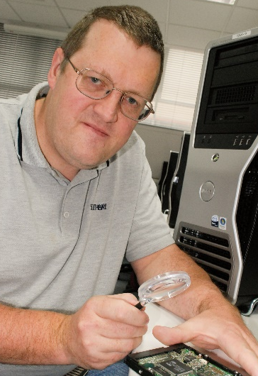
Speaker’s Profile

Geraint Williams is the CISO at GRC International Group. Geraint is a knowledgeable and experienced Information Security consultant with experience including vulnerability testing, digital forensics, secure networking, and wireless security issues.

Geraint has a strong technical knowledge of security and IT infrastructure including high performance computing. Geraint has a number of certifications in security and digital forensics including CISSP, CISA, CEH and CHFI and is a Qualified Security Assessor for the Payment Card Industry (PCI).

Agenda:

18:00pm | - Registration, refreshments and networking
18:15pm | - Presentation - Ransomware! Kill chain and Defence!
17.15pm | - Questions
17.45pm | - Networking

Please register to attend this talk at: https://ransomware-kill-chain-and-defence.eventbrite.com

