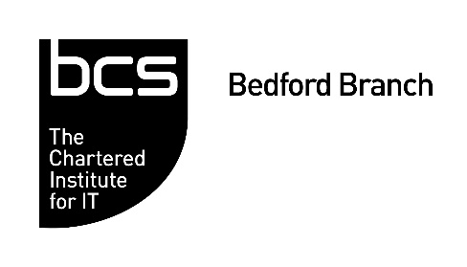
AI – Deep Learning
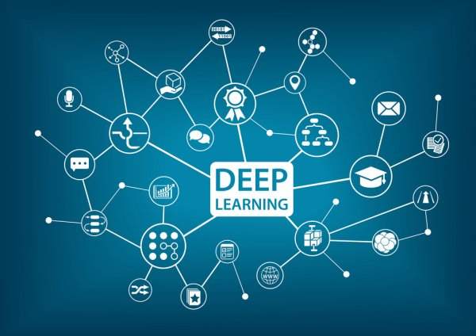 | By George Yazigi Digital Systems Architect and Manager - DARTeC  Cranfield University  Monday, 15th March 2021  7.00 – 8.30pm  Online  (Registration starts at 6:45pm)

Register online at: https://15032021bedford.eventbrite.co.uk
Moore’s Law which sustained the exponential progress in Microelectronics in the past five decades is expected to come to an end by 2022. Concentrating billions of transistors on a chip has led to an unprecedented growth in Artificial Intelligence research particularly in Machine Learning and Deep Learning. However, unless new technology is invented, this growth may not be sustainable at the current rate in the future!

Deep Learning is a sub-branch of Machine Learning focusing on algorithms inspired by the structure and function of the human brain called Artificial Neural Networks [ANN for short] and primarily relying on innovative coding techniques and advances in microelectronics to achieve unprecedented inferences results.

Let’s explore how Machine and Deep Learning can help in forecasting outcomes. And experience a live experiment to predict certain COVID19 variables! For example when the pandemic would reach the final phase in the UK or the USA!

Mr. George Yazigi is currently the Digital Systems Architect and Manager at the Digital Aviation Research Centre (DARTeC), Cranfield University.
He has more than 20 years of experience in software engineering, computer and data science, architecting and designing digital security systems and intelligent software platforms based on Big Data Analytics, Computational Intelligence and Machine Learning.

Agenda
6.45pm | Sign in – Welcome - Networking
7.00pm | AI – Deep Learning – George Yazigi
7:50pm | Virtual Coffee/Tea break
7:55pm | Live Machine & Deep Learning Experiment
8.15pm | Q & A and Networking

