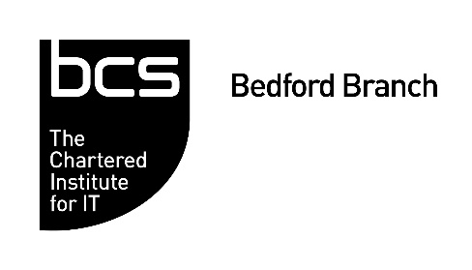
Exciting times for UK FinTech?
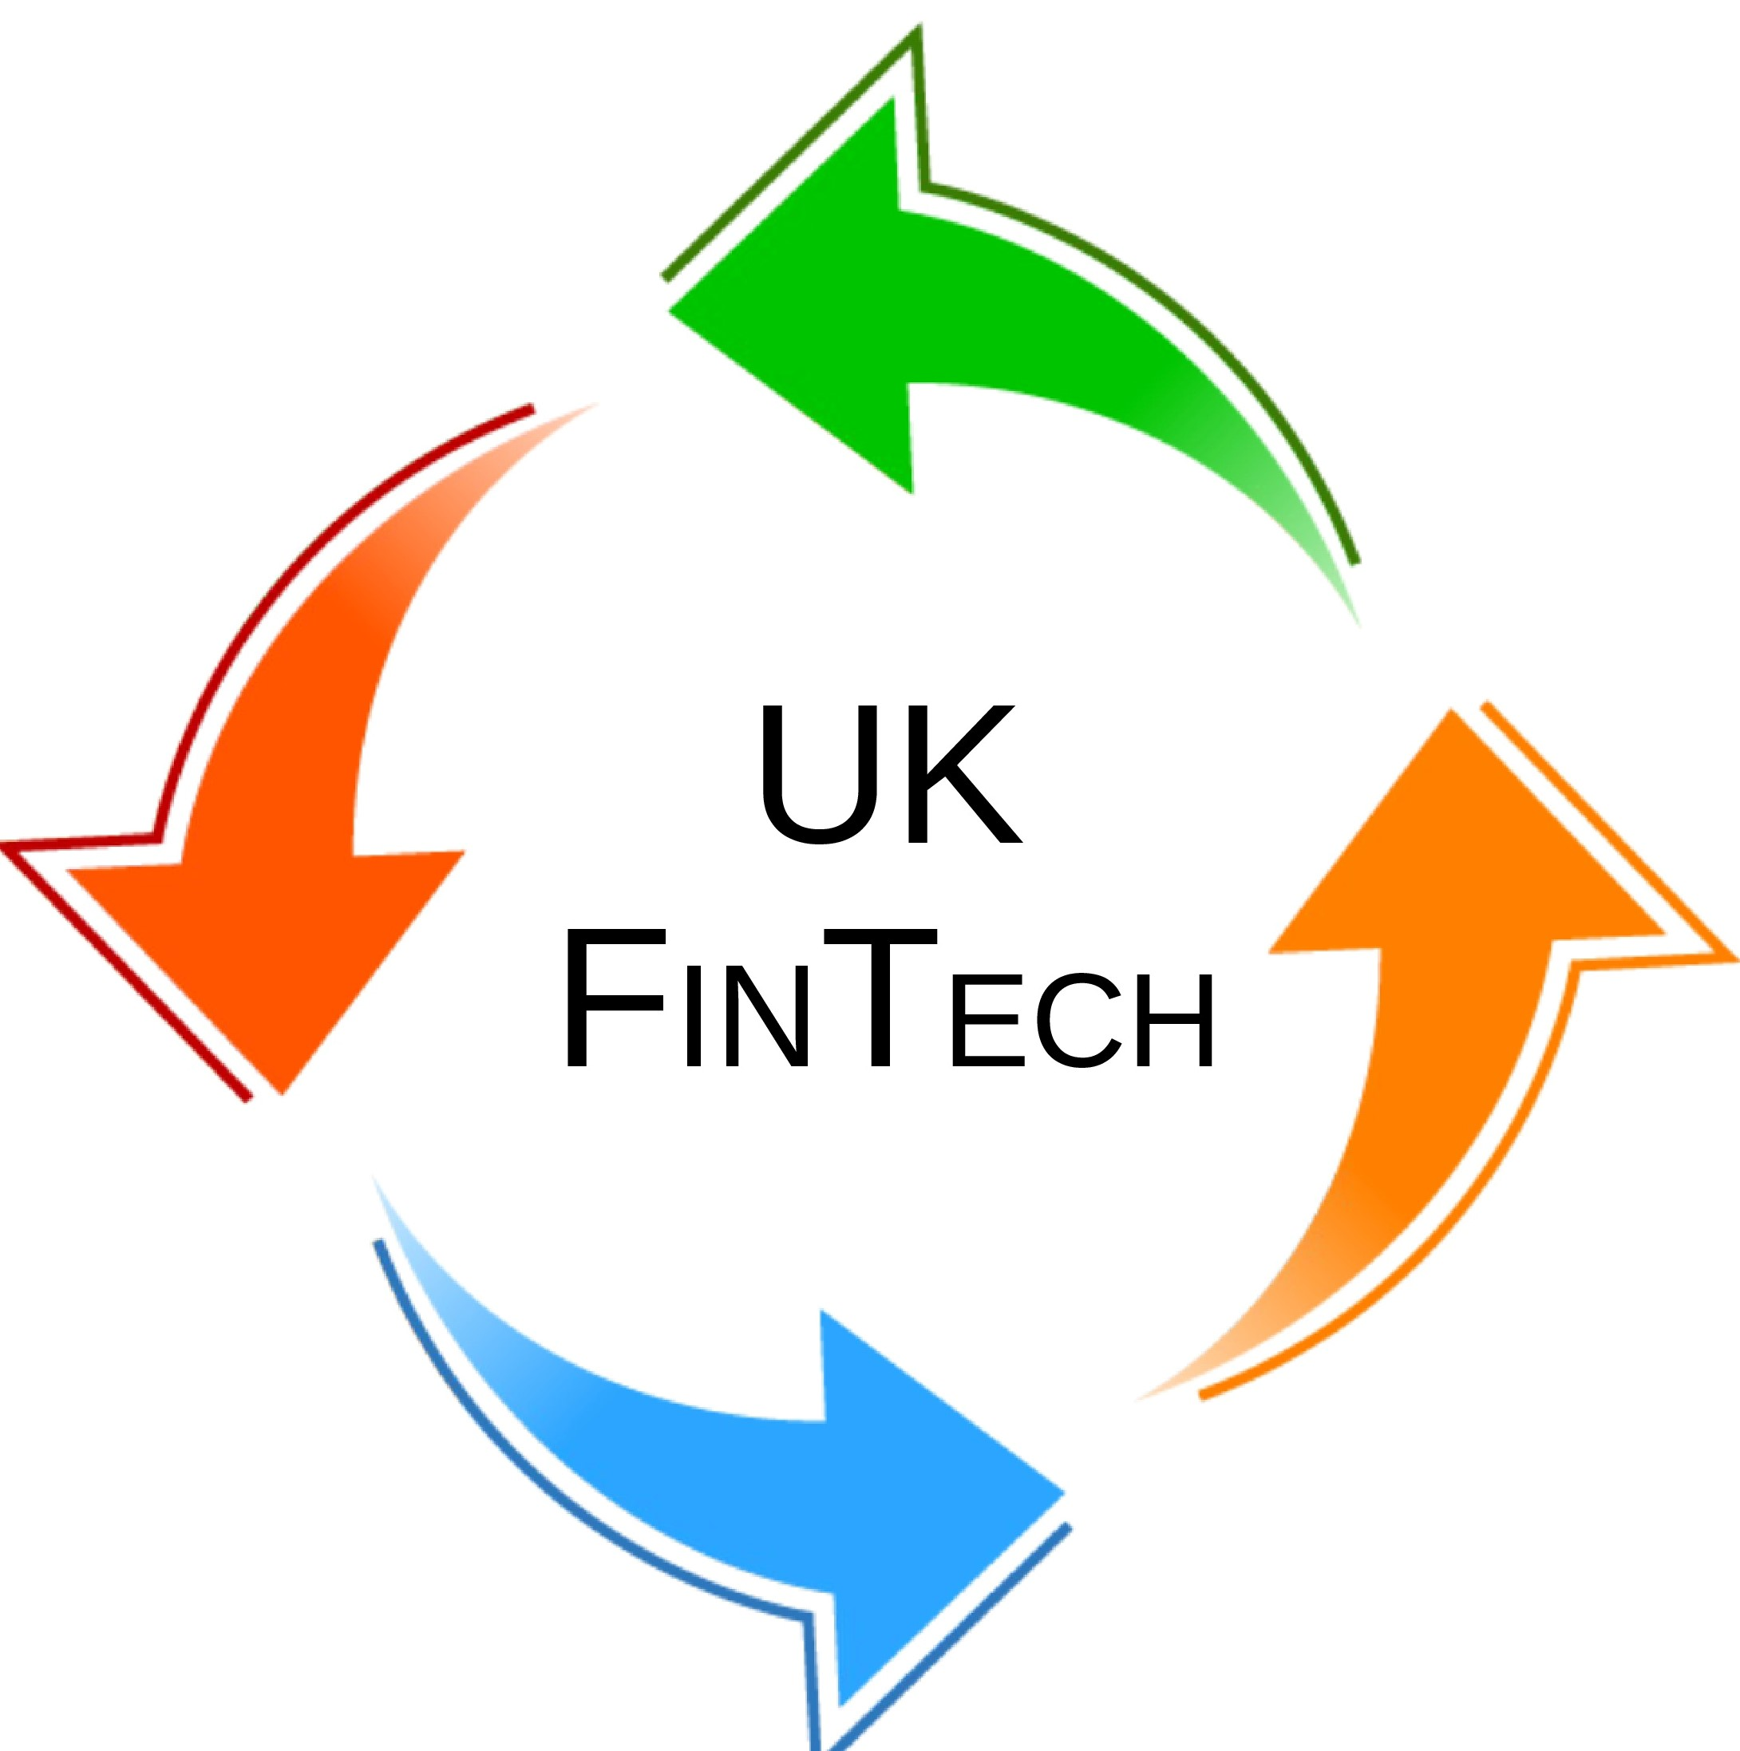
Dr. James Hood-Smith MBCS,
Co-Founder and CTO
Fregnan Limited

Monday, 10th May 2021
7.00 – 8.30pm

Online
(Registration starts at 6:45pm)
Register online at: https://bed100521.eventbrite.co.uk

The findings and recommendations of the recently published Kalifa Review suggest that FinTech in the UK will continue to be a big thing. But what is FinTech? And why should we - as IT professionals - be interested in it?
This talk will answer these questions by looking at examples of FinTech companies and the tech that supports them. It will look at each of the FinTech specialisms identified by the Kalifia Review: Banking, RegTech, InsurTech, Lending, Business Banking, Payments, Quote Aggregators and - the specialism of the speaker's own company - WealthTech.
The intended audience for the talk is IT professionals new to FinTech. It requires no prior knowledge or background in finance.
The intention is that all members of the audience leave the talk with an understanding of both how FinTech is delineated into its different specialisms and why and how FinTech is disrupting established industry. Throughout the talk there will be links to particular APIs, libraries and frameworks that are used in FinTech. There is thus the additional intention that all members of the audience leave with an appreciation of some of the technical skills and competencies required for working in this exciting field.

About the speaker
Dr James Hood-Smith MBCS, is a computer scientist, software developer and teacher. He is a co-founder and CTO of Fregnan Ltd, a FinTech startup that makes software for streamlining and semi-automating the production of equity research. Fregnan's customers include banks, fund managers, stock exchanges and research houses. James has a PhD in Computer Science from the University of Exeter and an MSc in Learning and Teaching from the University of Oxford.
Agenda
6.45pm | Sign in – Welcome - Networking
7.00pm | Dr James Hood-Smith MBCS – Exciting times for UK FinTech
8:00pm | Networking
8.15pm | Main session closes. System open for networking until everyone leaves

